

Practices for Secure Software Report

Table of Contents
Document Revision History 3
Client 3
Instructions 3
Developer 4
1. Algorithm Cipher 4
2. Certificate Generation 4
3. Deploy Cipher 4
4. Secure Communications 4
5. Secondary Testing 4
6. Functional Testing 4
7. Summary 4
8. Industry Standard Best Practices 4

Document Revision History

Version | Date | Author | Comments
1.0 | October 20th 2026 | Kyle Grady | Completed secure communications implementation, checksum verification, and security testing for Artemis Financial.

Client



Instructions

Submit this completed practices for secure software report. Replace the bracketed text with the relevant information. You must document your process for writing secure communications and refactoring code that complies with software security testing protocols.

- Respond to the steps outlined below and include your findings.
- Respond using your own words. You may also choose to include images or supporting materials. If you include them, make certain to insert them in all the relevant locations in the document.
- Refer to the Project Two Guidelines and Rubric for more detailed instructions about each section of the template.

Developer
Kyle Grady

Algorithm Cipher

For Artemis Financial, I selected SHA-256 to create a secure checksum for verifying data integrity. SHA-256 is part of the SHA-2 family of cryptographic hash algorithms and produces a 256-bit hash value. Unlike encryption, hashing is a one-way process. The resulting hash cannot be decrypted to recover the original information.
I chose SHA-256 because it is widely used, well-established, and significantly more resistant to collision attacks than older algorithms such as MD5 and SHA-1. SHA-256 helps identify whether information has been modified because changing the original input should produce a different hash value.
I also considered the importance of key length, algorithm strength, and the purpose of different cryptographic methods. Symmetric encryption uses the same secret key for encryption and decryption, while asymmetric encryption uses a public and private key pair. Both approaches have important roles in secure communications.
For the SSL certificate, I used an RSA 3072-bit key pair and the SHA256withRSA signature algorithm. RSA provides asymmetric cryptographic capabilities, while SHA-256 supports the certificate's digital signature. The certificate supports HTTPS by allowing the server to participate in TLS authentication. Actual TLS session encryption is negotiated between the client and server.
Together, these cryptographic technologies support different security objectives: SHA-256 provides integrity verification, and TLS provides encrypted communications.

Certificate Generation
To improve the security of the Artemis Financial application, I generated a self-signed SSL certificate using Java's Keytool utility.
The certificate was created using a 3072-bit RSA key pair and the SHA256withRSA signature algorithm. I stored the certificate and private key in a PKCS12 keystore named artemis-keystore.p12, using the alias artemis.
I also exported the certificate into a separate file named artemis-certificate.cer.
The certificate was configured for local testing with localhost and 127.0.0.1. Generating this certificate allowed the application to support HTTPS connections rather than transmitting information over unencrypted HTTP.
Because this was a self-signed certificate, it was appropriate for local development and testing but would need to be replaced with a certificate issued by a trusted certificate authority for production deployment.

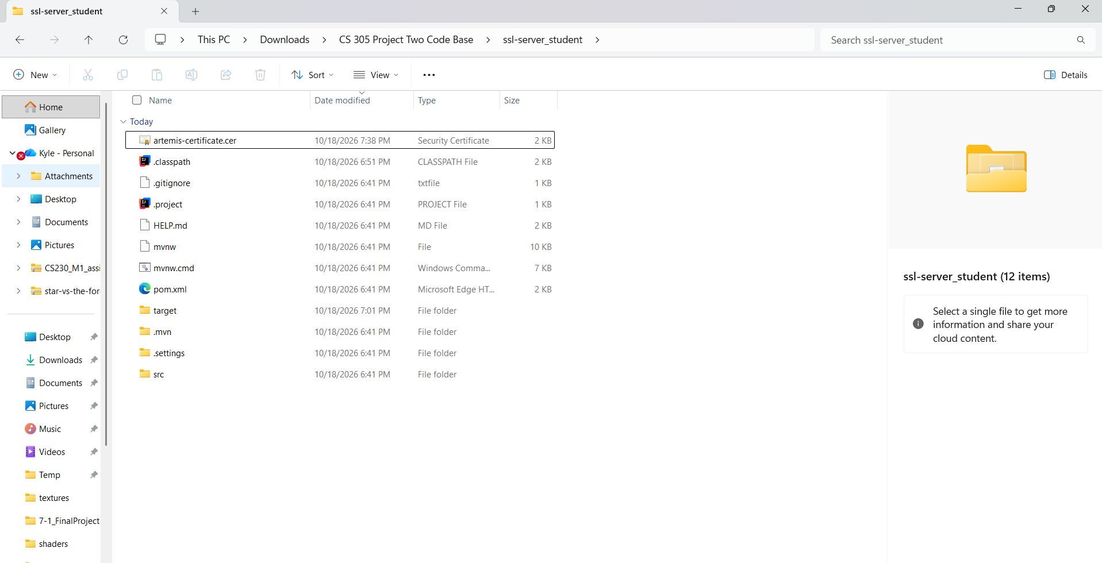

Deploy Cipher
After selecting SHA-256, I implemented a checksum feature in the application's Java code.
I created a /hash endpoint in the HashController class. This endpoint uses Java's MessageDigest functionality to calculate a SHA-256 hash from a unique string containing my name and information identifying the project.
The original input was:
Kyle Grady - Artemis Financial Secure Checksum 2026
The application generated the following SHA-256 checksum:
564737a3ff7464ee7f73a1fad397b97d1f47c99f7184b4498b2ba7dd58310726
I tested the endpoint and confirmed that it returned both the original input and the calculated checksum. This demonstrated that the hashing functionality was working correctly.
Using a cryptographic hash provides a way to check data integrity by comparing calculated hash values. It does not encrypt the original information or provide confidentiality on its own.
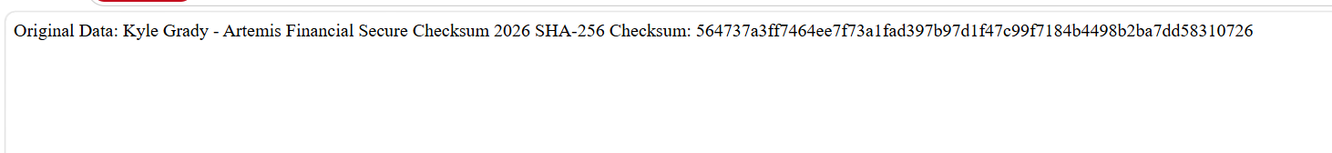

Secure Communications
To establish secure communications, I configured the Artemis Financial Spring Boot application to use HTTPS.
I updated the application.properties file to enable SSL, specify the keystore, and configure the application to run on port 8443.
The configuration used the following settings:
- server.port=8443
- server.ssl.enabled=true
- server.ssl.key-alias=artemis
- server.ssl.key-store=classpath:artemis-keystore.p12
- server.ssl.key-store-type=PKCS12
I configured the keystore password through an environment variable rather than placing the password directly into the application properties file. This helped avoid exposing the password in the source code.
After starting the application, I accessed the checksum endpoint using:
https://127.0.0.1:8443/hash
The application successfully responded over HTTPS. I also verified the connection using a curl request, which returned an HTTP 200 response and the expected checksum.
The browser displayed a certificate warning because the certificate was self-signed and not trusted by a public certificate authority. However, the successful HTTPS connection demonstrated that TLS was enabled for local testing.

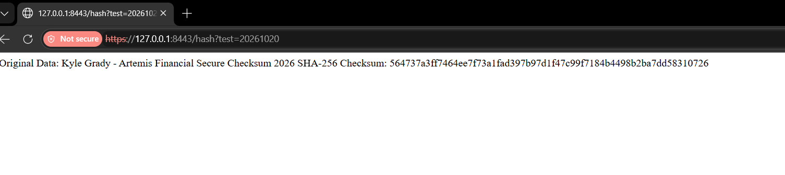

Secondary Testing
After completing the security changes, I performed secondary testing using the OWASP Dependency-Check Maven plugin.
I configured Dependency-Check version 12.1.0 and ran a scan against the application's dependencies. The initial scan encountered an authentication error from the Sonatype OSS Index service. I corrected the plugin configuration by disabling that analyzer while retaining the other enabled vulnerability analyzers.
After making the correction, I ran Dependency-Check again. The analysis completed successfully, and Maven displayed BUILD SUCCESS.
The generated report identified the following results:
- Dependencies scanned: 49
- Unique dependencies: 31
- Vulnerable dependencies: 16
- Vulnerability findings: 295
Several findings were associated with older versions of Spring Framework, Spring Boot, Apache Tomcat, Jackson Databind, and SnakeYAML.
For example, the report identified CVE-2022-22965 in the Spring Framework dependencies and CVE-2022-1471 in SnakeYAML. These findings demonstrate why dependency scanning is important, even when the application's own code executes correctly.
The reported vulnerabilities have not all been remediated. Since the project uses older framework and library versions, updating affected dependencies to supported, patched releases should be a priority before production deployment.
The scan confirms that known vulnerabilities remain in the dependency set. A direct comparison against a baseline scan of the original application would be necessary to determine conclusively whether the refactoring introduced any additional dependency vulnerabilities.
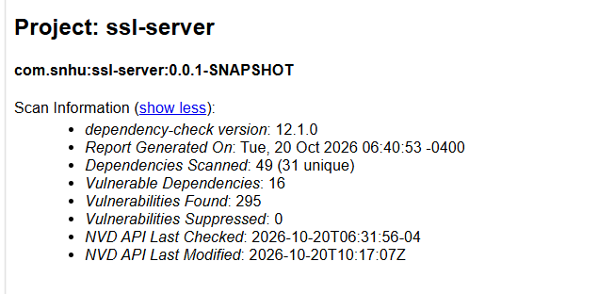
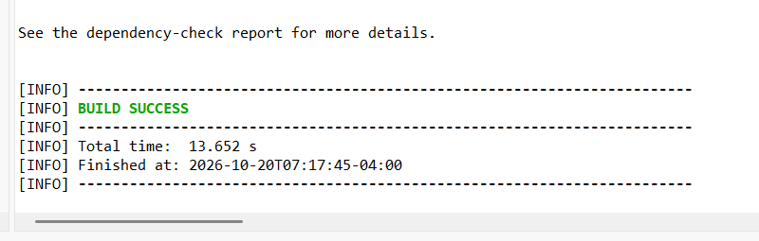

Functional Testing
After implementing the SHA-256 checksum and HTTPS configuration, I performed functional testing to confirm that the application continued operating as expected.
I started the Spring Boot application and accessed the /hash endpoint through HTTPS on port 8443.
The application successfully returned the original test string and its SHA-256 checksum. I also used the following command to test the application:
curl.exe -k -i https://127.0.0.1:8443/hash
The command returned HTTP/1.1 200, indicating that the request was processed successfully. The -k option allowed curl to accept the self-signed certificate during local testing.
I also tested the endpoint in a web browser and confirmed that the expected information appeared.
These tests verified that the checksum endpoint functioned correctly and that the application could communicate over HTTPS. They did not constitute a complete penetration test or establish that every component of the application was free from security vulnerabilities.

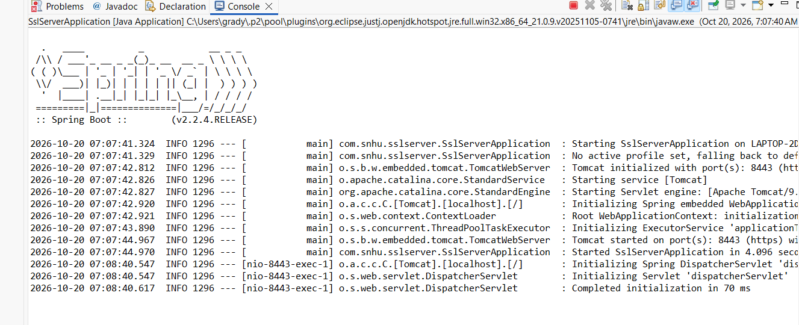

Summary

Throughout this project, I improved the security of the Artemis Financial application by implementing cryptographic hashing, configuring HTTPS, generating an SSL certificate, and performing dependency vulnerability testing.
One of the most important improvements was adding SHA-256 checksum functionality. This provided a way to verify the integrity of information and detect unexpected changes.
Another important improvement was enabling HTTPS. By configuring a certificate and keystore, I established encrypted communication between the application and its clients during local testing.
I also used OWASP Dependency-Check to evaluate the application's third-party libraries. Although the scan completed successfully, it identified known vulnerabilities in several older dependencies. This demonstrated that application security requires more than adding encryption or secure endpoints. Developers must also monitor the libraries and frameworks their applications depend on.
The testing process confirmed that the refactored application could successfully generate a checksum and respond to HTTPS requests. The next security improvements should focus on updating vulnerable dependencies, validating compatibility after upgrades, and using a trusted certificate for production deployment.
Overall, this project helped me better understand how cryptography, secure communications, vulnerability scanning, and functional testing work together to improve software security.

Industry Standard Best Practices

Several industry-standard practices can help maintain the security of the Artemis Financial application.
One important practice is using established cryptographic algorithms rather than creating custom encryption or hashing methods. SHA-256 is a widely recognized cryptographic hash algorithm, and TLS is an established standard for protecting information transmitted across networks.
Another best practice is protecting sensitive configuration information. Instead of storing the keystore password directly in source code, I used an environment variable. In a production environment, additional protection could include a dedicated secrets management system and restricted access to private keys.
Regular dependency scanning is also important. Tools such as OWASP Dependency-Check help identify known vulnerabilities in third-party software. Developers should review the results, investigate possible false positives, and update vulnerable libraries when appropriate.
Following the principle of least privilege can further reduce security risks. Applications should only have access to the permissions and resources necessary for their intended functions.
Additional practices include validating user input, maintaining clear error handling, protecting sensitive data, and testing the application after making security changes.
Finally, security testing should be an ongoing part of software development rather than a one-time activity. Repeated vulnerability scans, functional tests, and code reviews can help identify weaknesses before an application is deployed.
By following these practices, Artemis Financial can work toward maintaining a more secure and reliable application while reducing the risk of unauthorized access, data exposure, and exploitation of known vulnerabilities.

